This document is merely to point out the differences in confessional count numbers between my findings and the official numbers posted on Survivor Sucks. The guidelines I use can be found [here](https://docs.google.com/document/d/18ofsPiVWxSejzSjEGlU8KEx4Og2ddEJScCV23RsCPIA/edit?usp=sharing).

**Survivor Sucks Season 08 Counts** ([link](https://goo.gl/photos/bobGgvuv3KYhadzp6))

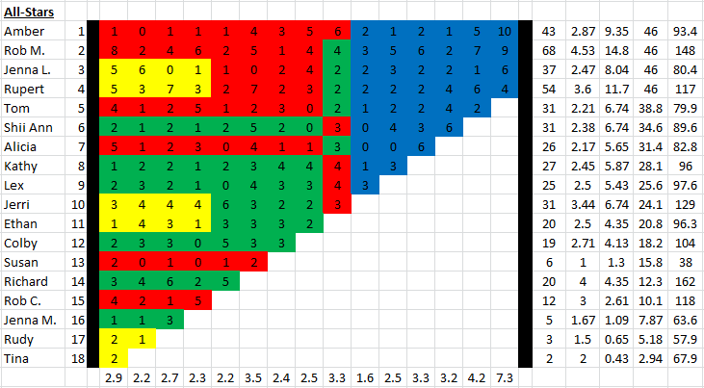

**My Season 08 Counts** ([link](https://goo.gl/photos/NLcMJPybjBo541tcA))

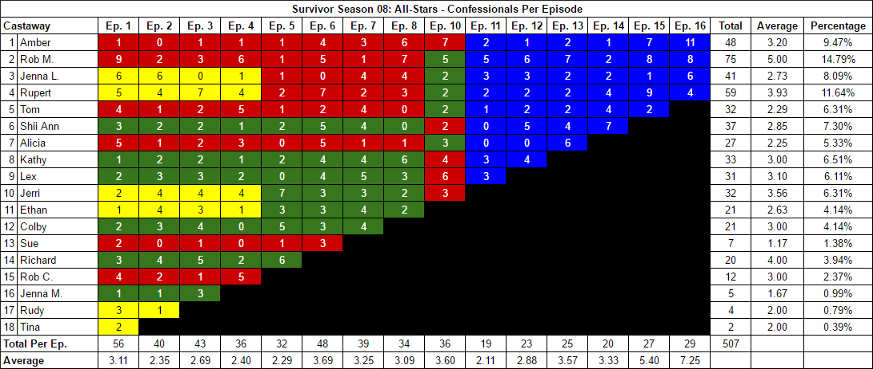

[Survivor Sucks Season 08 thread](http://survivorsucks.yuku.com/topic/4304).

**Differences**

[Episode 01](https://docs.google.com/document/d/1GBgZXtosKoTUaNlloWCYFHmvHLM_qPCi211l-ppEqMw/edit?usp=sharing)

* **Rob M. 9 (+1)** Confessional #50 has an 11 second gap followed by a voice over. This is the only significant consecutive gap for Rob M.
* **Jenna L. 6 (+1)** I got a count of 6 for Jenna L. instead of the established 5. No significant gap.
* **Shii Ann 3 (+1)** I got a count of 3 for Shii Ann instead of the established 2. No significant gap.
* **Jerri 2 (-1)** I got a count of 2 for Jerri instead of the established 3. No significant gap.
* **Rudy 3 (+1)** Confessional #28 is an on-the-fly confessional where Rudy looks directly at the camera and narrates the “right” way to make fire while his tribemates work behind him.

[Episode 02](https://docs.google.com/document/d/1C9QppTXv6I1ShmtbBz71CrU8k_VhBgAIw_Xi0mWjGbI/edit?usp=sharing)

* **Rupert 4 (+1)** I got a count of 4 for Rupert instead of the established 3. No significant gap.
* **Shii Ann 2 (+1)** Confessional #8 is a voice over that brought Shii Ann’s count to 2.

[Episode 03](https://docs.google.com/document/d/19pCkMrTuZAO9tAM5AA4r1JflCO3Jh7Ns9fOoDPMSvDk/edit?usp=sharing)

* **Rob M. 3 (-1)** I got a count of 3 for Rob M. instead of the established 4. No significant gap.
* **Lex 3 (+1)** Confessionals #25-26 are dual confessionals between Lex and Colby. Both look directly at the camera during the confessionals. This raised both of their counts by 1.
* **Colby 4 (+1)** See comment for Lex above.
* **Richard 5 (-1)** Richard has an established count of 6 for this episode. However, I got 5 for him. There is only one instance where that missing confessional was probably originally counted. It happens between confessionals #38-39. Richard goes to get Tree Mail and talks out loud as he does so. He never looks directly at the camera so that’s why I disregarded it. He says: *"We wouldn't lose. We haven't lost a thing yet. The arm's up, so I'm assuming... we have mail. Yeah, baby. Better be a clue. I'm not waiting to open it. Oh, it's a map, and it's clue two. Yeah, baby. Clue two for rice. That's so much more important than anything else."*

[Episode 04](https://docs.google.com/document/d/1YeSXuITjiQ9pPWLkLU5NdKUq41kql9Aedl-4yRxQTt0/edit?usp=sharing)

* **Rupert 4 (+1)** I got a count of 4 for Rupert instead of the established 3. No significant gap.
* **Lex 2 (+1)** I got a count of 2 for Lex instead of the established 1. No significant gap.
* **Note:** Confessional #23 is a Rob C. confessional. It has a significant gap. I revised it multiple times and my prevalent time gap was of 9s. However, it is very close to 10s, like in the 9.90’s, and I even got 10s flat on it at times. Like I said, I went with my prevalent reading of 9s, but it is worth revising. Having a 9s gap, leaves his count at the established 5. If it was a 10s gap, it would rise his count to 6 (+1).

[Episode 05](https://docs.google.com/document/d/12p7YF-1QaS_FMuILy_LRZzAxn7rMRIqEJrtW397Z5a8/edit?usp=sharing)

* **Rob M. 1 (-1)** I got a count of 1 for Rob M. instead of the established 2. No significant gap.
* **Jerri 7 (+1)** Two significant confessionals:
  + Confessional #13 has a 14s gap
  + Confessional #29 is a voice over
* **Richard 6 (+1)** Confessional #30 has a 12s gap which brought Richard’s count up by 1.

[Episode 06](https://docs.google.com/document/d/1DkK70frgvbp-Fp3sbqFCtwQtqLDeVk3isKZ2c2x2aIc/edit?usp=sharing)

* **Alicia 5 (+1)** I got a count of 5 for Alicia instead of the established 4. No significant gap.
* **Kathy 4 (+1)** Confessional #2 has a 12s gap. This brought Kathy’s count up by 1.
* **Sue 3 (+1)** Confessional #8 is an on-the-fly confessional where Sue narrates to the camera as she gathers snails. I included it, which raised her count by 1.

[Episode 07](https://docs.google.com/document/d/1QTCjyjE9OyuzhkuKzWCCAdEjLj7PL0gO-kgiqHHE6iE/edit?usp=sharing)

* **Jenna L. 4 (+2)** Jenna L. has two significant gaps:
  + Confessional #15 has a 15s gap.
  + Confessional #16 has a 10s gap.
* **Tom 4 (+1)** Has two on-the-fly confessionals while fishing on the yacht which I counted:
  + Confessional #25 narrates to the camera and chyron is present on screen.
  + Confessional #27 is a continuation of #25. No chyron present.
* **Shii Ann 4 (+2)** Confessional #21 has a 10s gap.
* **Lex 5 (+2)** I got a count of 5 for Lex instead of the established 3. No significant gap.
* **Jerri 3 (+1)** I got a count of 3 for Jerri instead of the established 2. No significant gap.
* **Ethan 4 (+1)** Confessional #28 has a 15s gap.
* **Colby 4 (+1)** I got a count of 4 for Colby instead of the established 3. No significant gap.

[Episode 08](https://docs.google.com/document/d/1_iwq5p8_MVexktDArAKiCblZaM_IbixdrnpxSOzjqT4/edit?usp=sharing)

* **Amber 6 (+1)** Confessional #21 is a voice over.
* **Rob M. 7 (+3)** The only significant gap is confessional #25 which has a 10s gap.
* **Kathy 6 (+2)** Confessional #1 is an on-the-fly confessional where Kathy narrates to the camera as she tries to keep the fire on during a rainstorm. There are even voice over elements. No chyron present.

[Episode 10](https://docs.google.com/document/d/1E7U8n_JYcAXaNGcxF5C1FxKjvvppapou3Md0hArg2sQ/edit?usp=sharing)

* **Amber 7 (+1)** Confessional #20 has a 10s gap.
* **Rob M. 5 (+1)** Confessional #27 has a 10s gap.
* **Shii Ann 2 (-1)** I counted 2 confessionals for Shii Ann instead of the established 3. No significant gap.
* **Lex 6 (+2)** I counted 6 confessionals for Lex instead of the established 4. No significant gap.
* **Note:** Confessional #6 is an on-the-fly Jerri confessional where she narrates directly to the camera at camp with tribemates walking behind her. No chyron present. This confessional did not affect her established count of 3.

[Episode 11](https://docs.google.com/document/d/1hBbSHcM7zHMszlo_XPP-xXksjWhC9P8gGEaNv5wfpGU/edit?usp=sharing)

* **Rob M. 5 (+2)** Confessional #13 has a 10s gap.
* **Jenna L. 3 (+1)** I counted 3 confessionals for Jenna L. instead of the established 2. No significant gap.
* **Kathy 3 (+2)** Confessional #18 has a 12s gap.

[Episode 12](https://docs.google.com/document/d/1m4Xd3b_n2KHRdzKNjA6BwIlSoE40ntAshnVlHAKpuE0/edit?usp=sharing)

* **Rob M. 6 (+1)** I got a count of 6 for Rob M. instead of the established 5. No significant gap.
* **Shii Ann 5 (+1)** Confessional #13 is a very unique confessional because Shii Ann starts to fade away as a new scene fades in. If you take into consideration the moment the scene starts to fade away, then there is a 10s gap, which is what I did, and this brought her count up by 1. If you instead wait until the last moment where Shii Ann completely disappears from her confessional, then there is a 9s gap, and her count would remain the same.
* **Kathy 4 (+1)** I got a count of 4 for Kathy instead of the established 3. No significant gap.

[Episode 13](https://docs.google.com/document/d/1In0oaMBUJXQ3pDzGpCqiDSyjMLkv773v7x2Ls-66xow/edit?usp=sharing)

* **Rob M. 7 (+1)** Confessional #17 is a voice over.
* **Shii Ann 4 (+1)** I got a count of 4 for Shii Ann instead of the established 3. No significant gap.

[Episode 14](https://docs.google.com/document/d/1Gud3rTS0kzXnkI4XDNN4rA8ndLnGZqm4X-8lwkKRLXg/edit?usp=sharing)

* **Shii Ann 7 (+1)** Confessional #1 has a 12s gap.
* **Notes:**
  + Confessional #8 is an on-the-fly Rob M. confessional at camp next to his brother. Chyron present.
  + Confessional #10 is an on-the-fly Tom confessional where Tom narrates directly to the camera as he carries a log with his son. No chyron present.

[Episode 15](https://docs.google.com/document/d/1iZXNcKb2dhXKVOVuR7D5Hsq2jsNQZCm3OiiZCNy4u88/edit?usp=sharing)

* **Amber 7 (+2)** Confessional #11 has a 13s gap. No other significant gaps.
* **Rob M. 8 (+1)** I got a count of 8 for Rob M. instead of the established 7. No significant gap.
* **Rupert 9 (+3)** Confessional #3 has an 11s gap. No other significant gaps.

[Episode 16](https://docs.google.com/document/d/1wUc6lpwyWI8q_70pArp7mgOuimQLEXsEPmdz3dqh0f4/edit?usp=sharing)

* **Amber 11 (+1)** I got a count of 11 for Amber instead of the established 10. No other significant gaps.
* **Rob M. 8 (-1)** The only significant gap is an 11s gap in confessional #26.

|  |  |  |
| --- | --- | --- |
| **Castaway** | **Count** | **Change** |
| Rudy | 4 | +1 |
| Sue | 7 | +1 |
| Colby | 21 | +2 |
| Ethan | 21 | +1 |
| Jerri | 32 | +1 |
| Lex | 31 | +6 |
| Kathy | 33 | +6 |
| Alicia | 27 | +1 |
| Shii Ann | 37 | +6 |
| Tom | 32 | +1 |
| Rupert | 59 | +5 |
| Jenna L. | 41 | +4 |
| Rob M. | 75 | +7 |
| Amber | 48 | +5 |
| **Total** | **507** | **+47** |

**Revised Sucks Counts** (link)